**EMG and IMU Data for Therapy Mapping**

**Problem Statement**

The main issue is the absence of a technological method to empirically measure and track muscle improvement during physical therapy sessions.

**Solution**

An EMG and IMU sleeve for rapid arm placement to track muscle changes accurately during therapy sessions. This system includes a high-fidelity, adjustable sensor sleeve for real-time data across the arm, a signal processing module for data analysis and movement pattern identification, and user customization tools for therapists to assess and share therapy effectiveness.

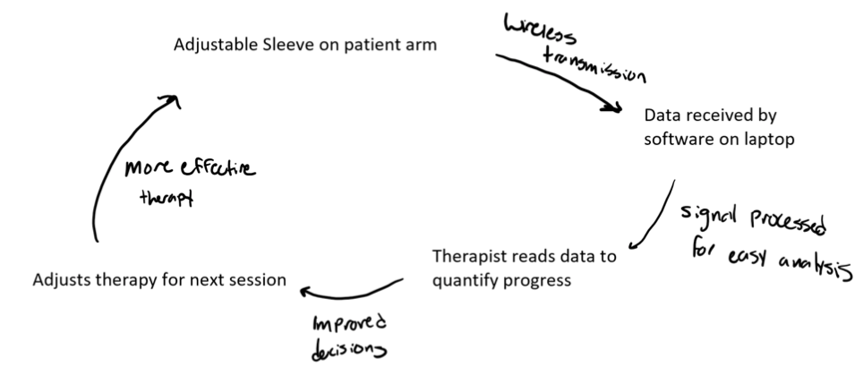

**User/Consumer**

The primary users are individuals undergoing upper extremity physical therapy, therapists, and educators in the field. They would use this technology to obtain quantifiable data on muscle function improvement, aiding in more effective and personalized therapy.

**Questions/Concerns:**

- What strategies can be employed to make the device affordable and accessible to all potential users?

- How will the user interface be designed to ensure it is intuitive and meets the diverse needs of users?

- What are the technical challenges in accurately interpreting EMG signals, and how can they be addressed?